

**Discipline**

**Testing & Deployment**

***(3 versions)***

**CS5201**

Stage-3

**Sheikh Muhammed Tadeeb (AU19B1014)**

* **Functionalities Implemented:**

1. **Authorization: -**

If I try to login with wrong login credentials the application won’t allow me to do that.

(Status: PASSED)

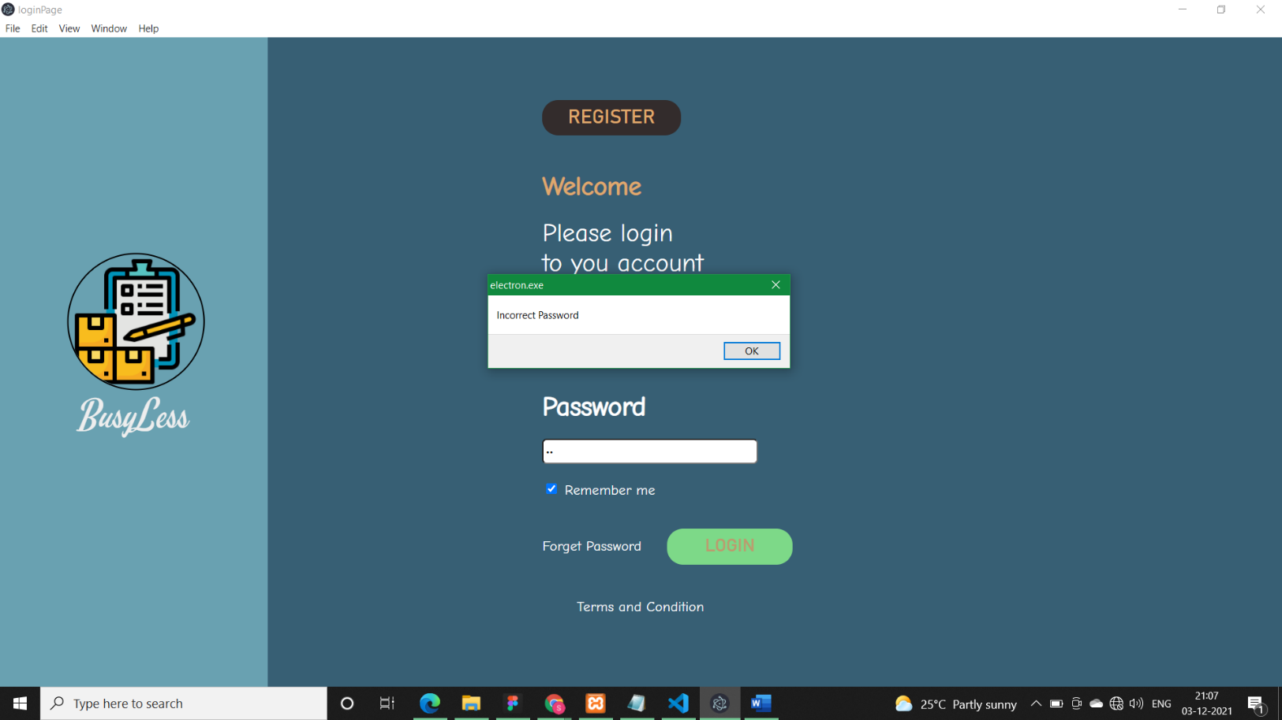

1. **Authentication: -**

To be a valid user of the system we must register into it.

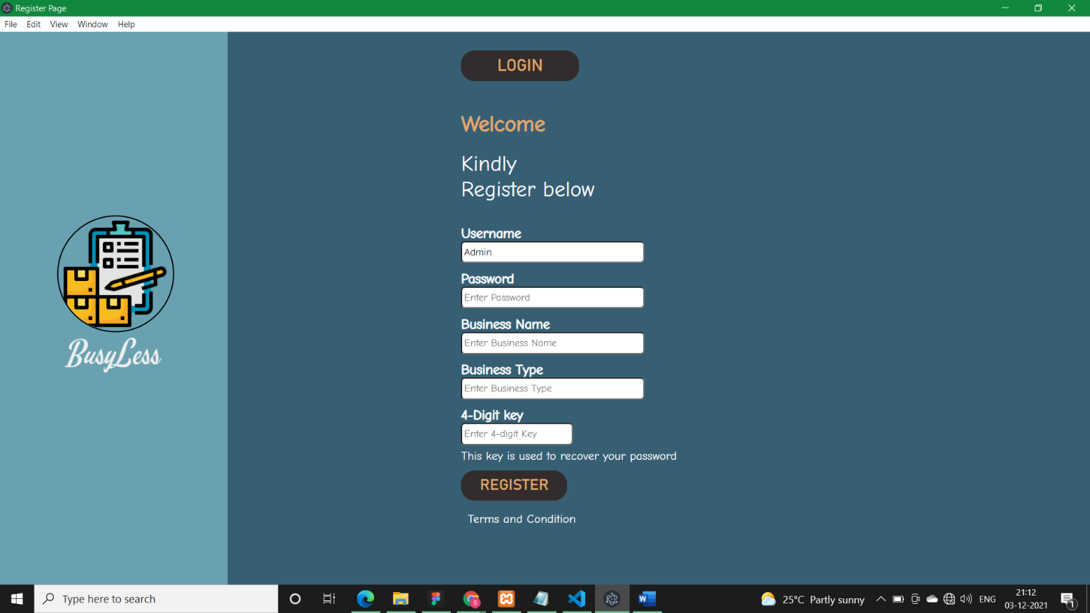(Status: PASSED)

1. **User-Control and freedom: -**

User has full control on the system as eve if he/she forgets the password they can recover it just by entering their key which they entered during their registration.

(Status: PASSED)

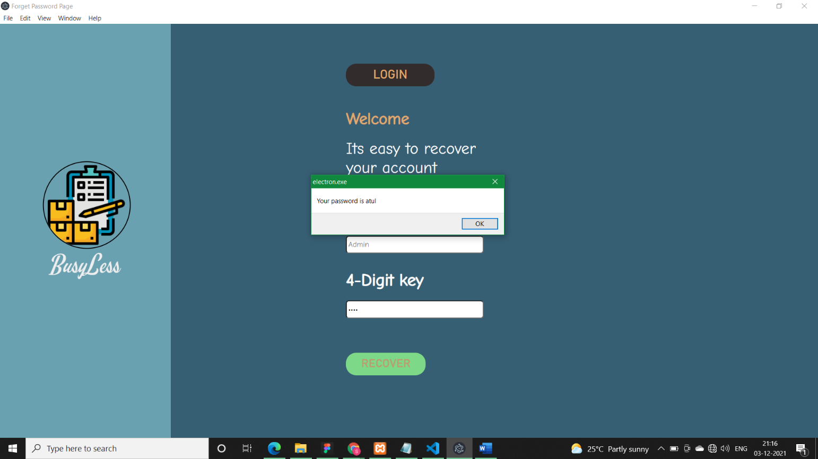

1. **Visibility of system status:**

Any action user does in the application has some feedback/response to the user by which the user feels connected with the system e.g.: hovering effects, login updates etc.

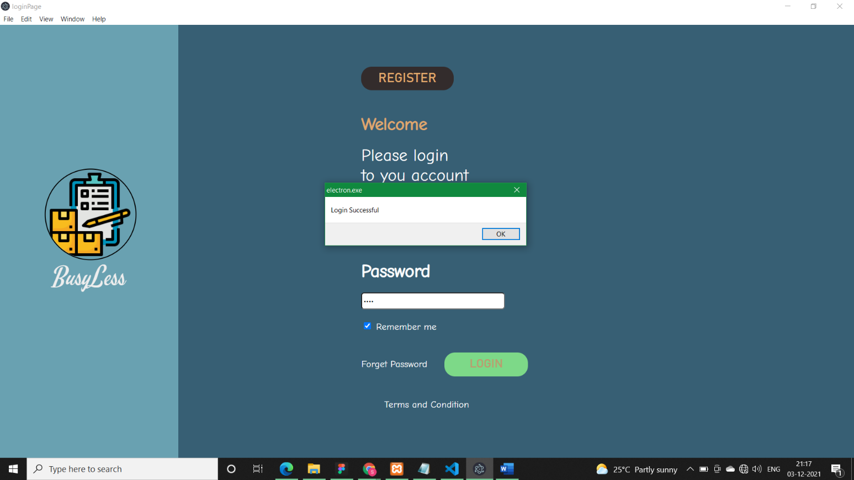(Status: PASSED)

1. **Error prevention:**

The user is provided with the validations which help the user to be free from errors while using the application.

(Status: PASSED)

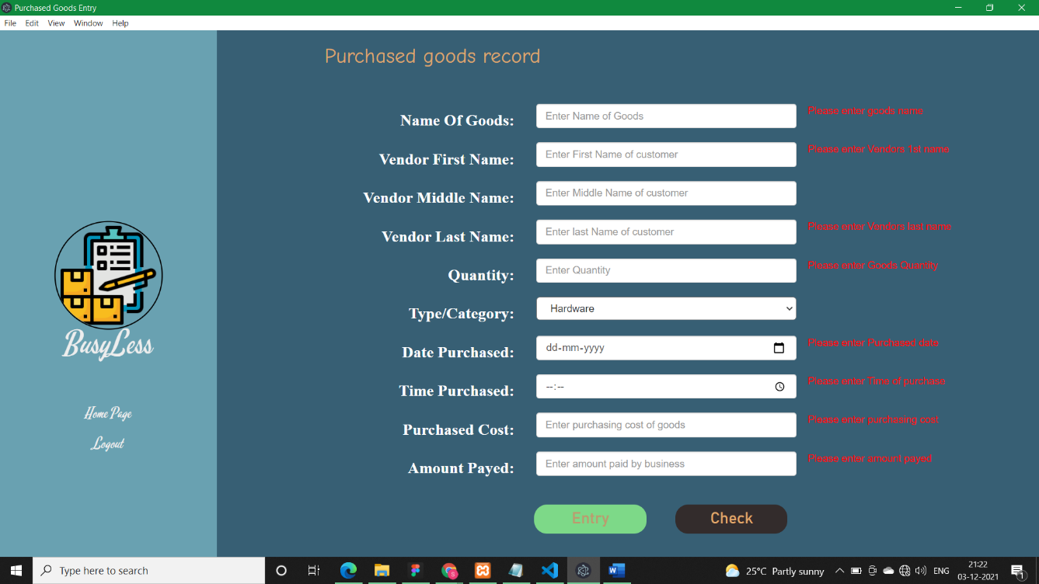

1. **Help and Documentation:**

The user is provided with a page to which he can browse and check how to use the application.

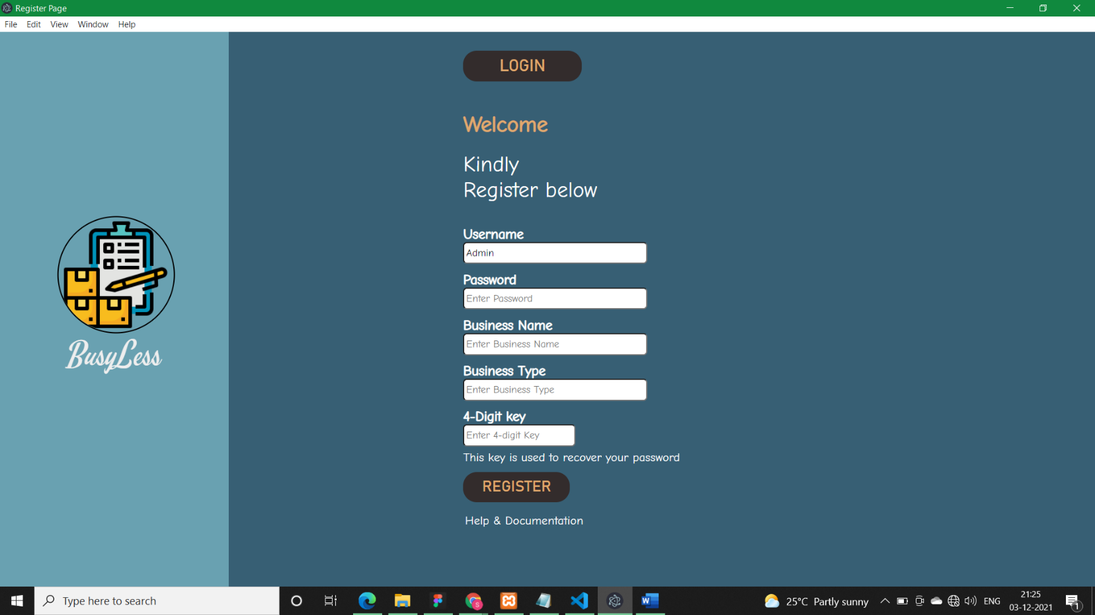(Status: PASSED)

* **Features added after review:**

1. **Numeric values:**

Allowing only numeric values in key at the time of registration. (Status: PASSED)

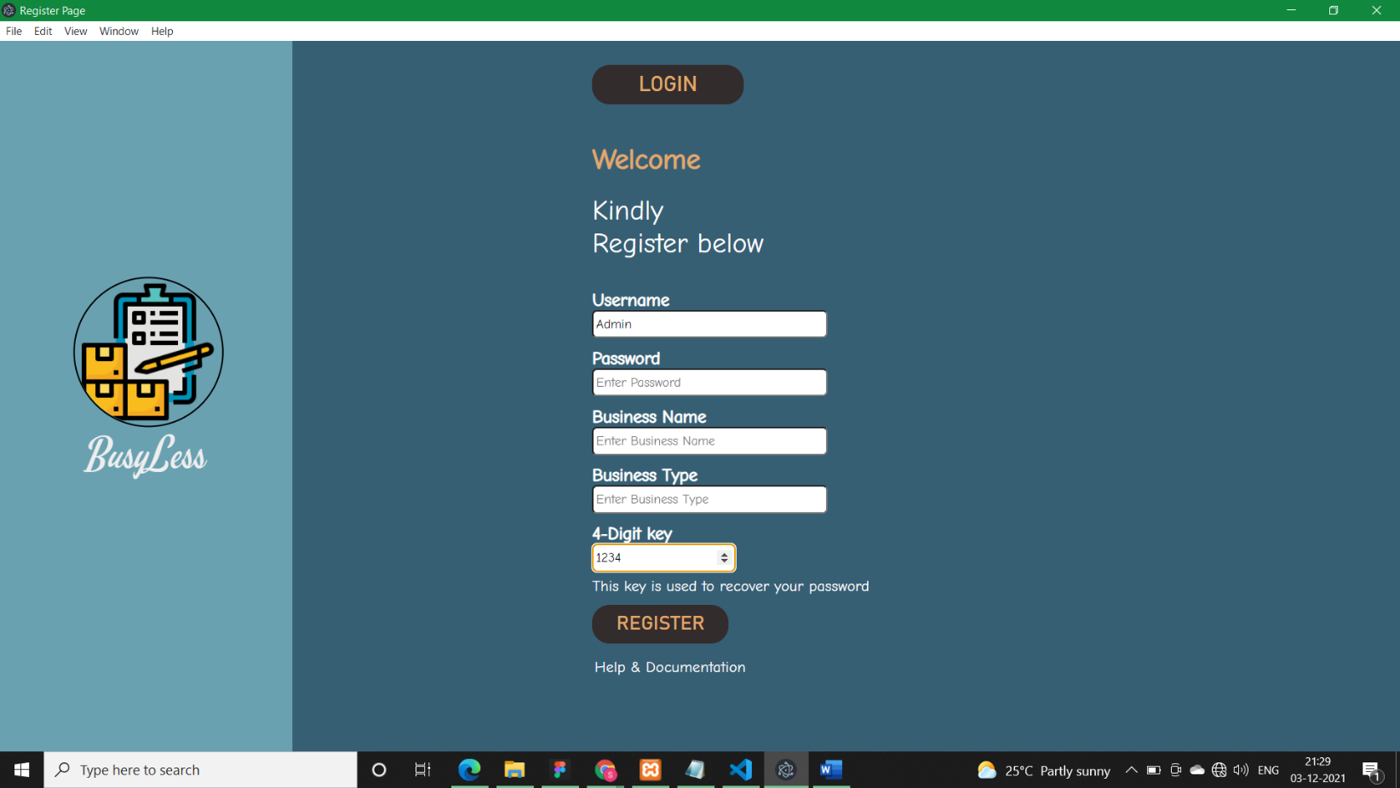

1. **Consistency & standard: -**

Consistency in color and font-style. I have changed it on forms and home page as well.

(Status: PASSED)

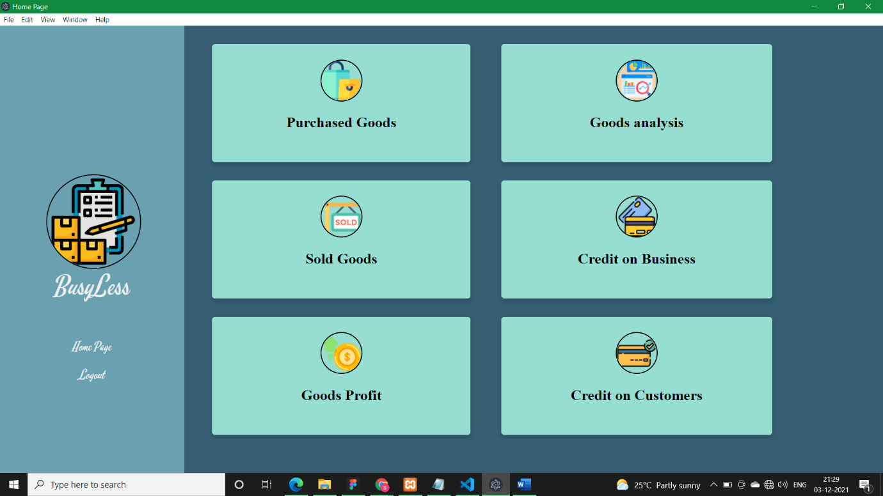

1. **Dropdown list:**

In business type I have given a dropdown list so that the user gets help from the application in quickly choosing the category/type of product. (Status: PASSED)

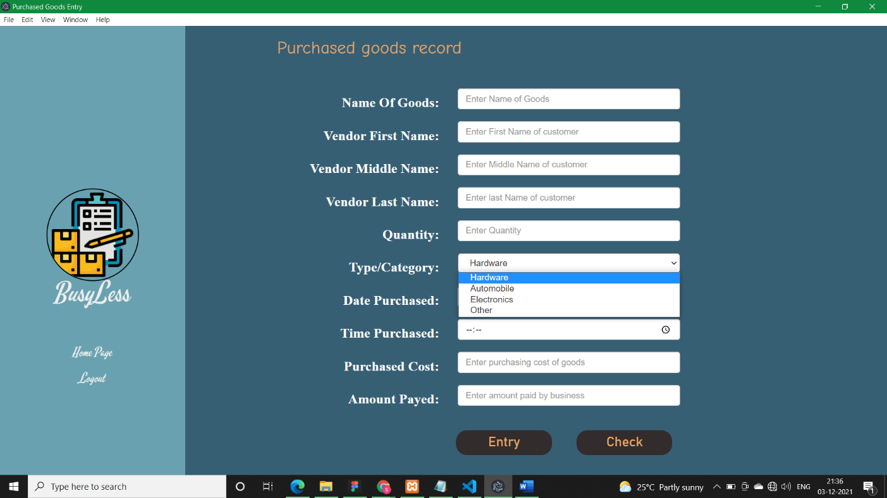

1. **Auto-generated Codes:**

Customer code will get automatically generated for new customers and will be fetched in the form from the database. (Status: PASSED)

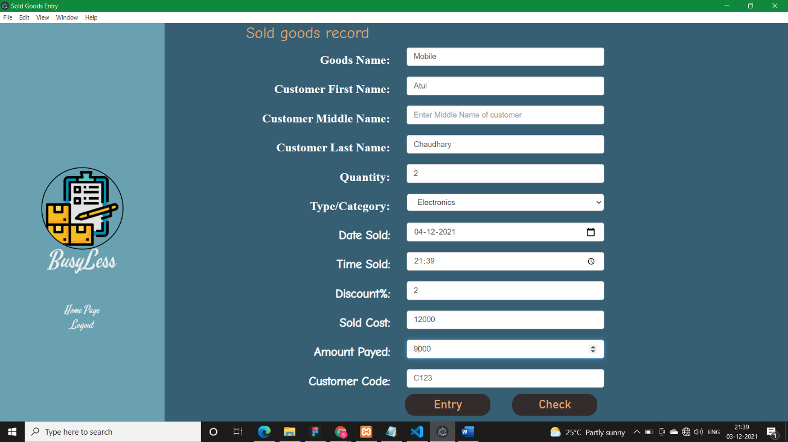

* **Packaging the Application: -**

To package my application, I have used electron-packager to package my application.

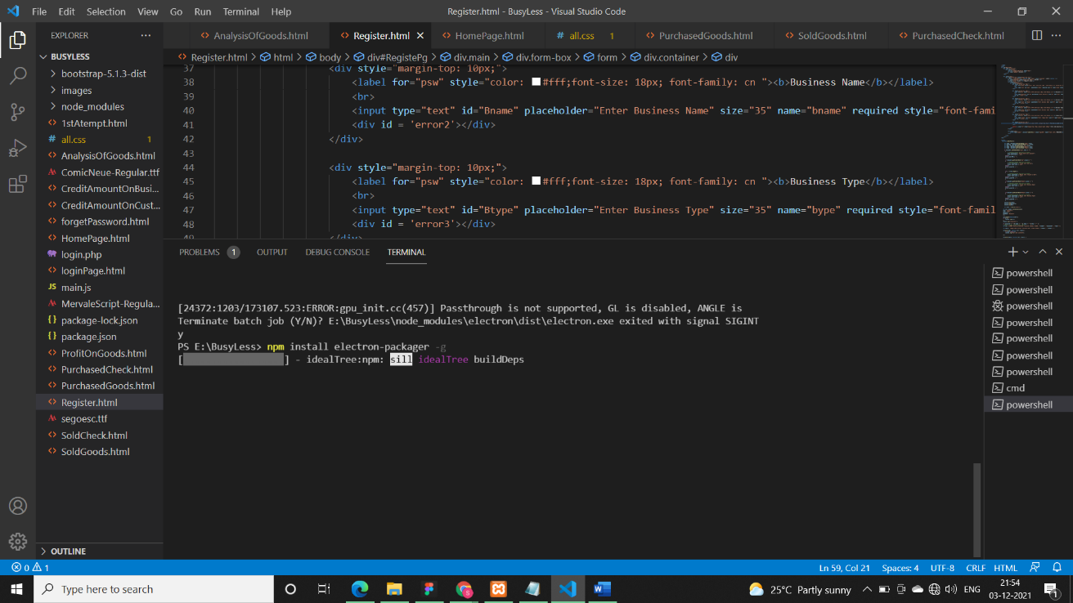

After installing electron-packager we need to package our app but it shows some error due to some PowerShell security policy, to fix it, I Just deleted electron-packager.ps1 file:

File C:\Users\Sheikh Tadeeb\AppData\Roaming\npm\electron-packager.ps1

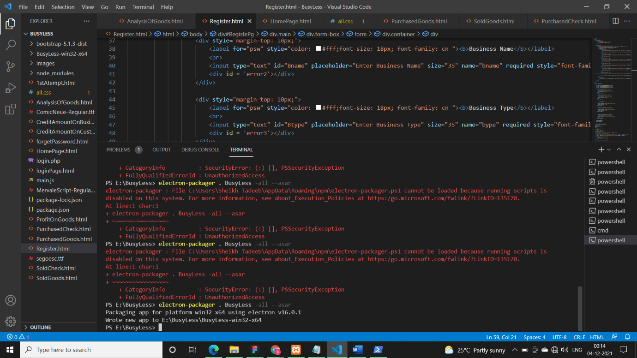

The Application is successfully packaged.

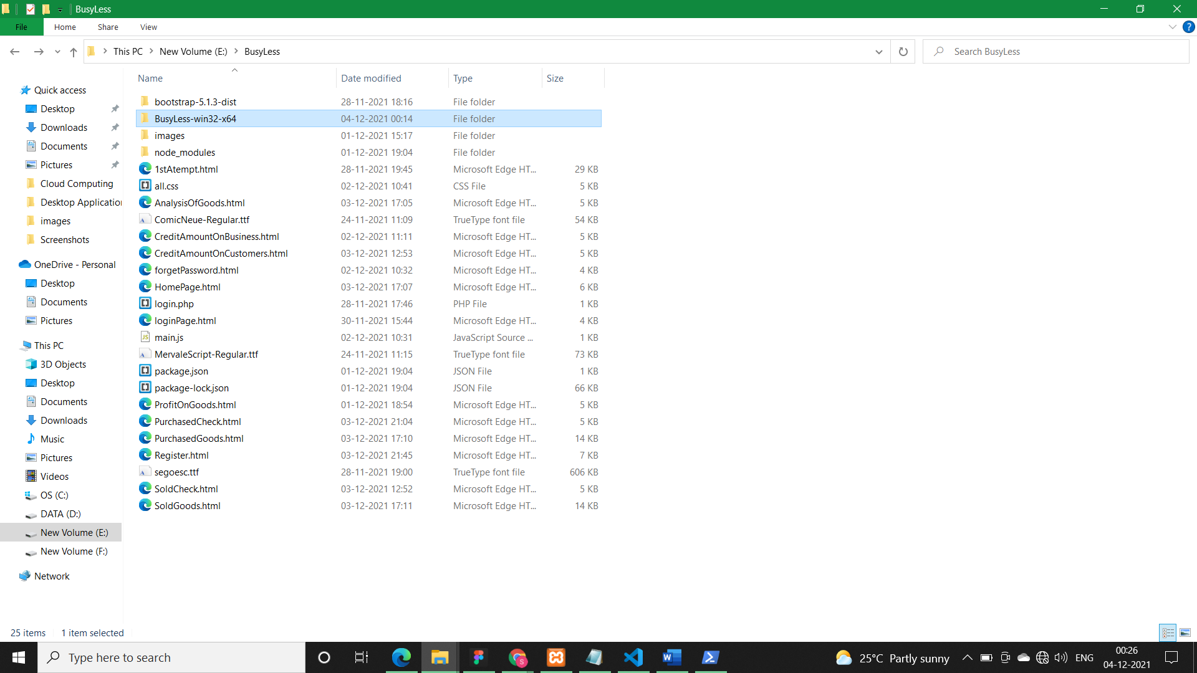

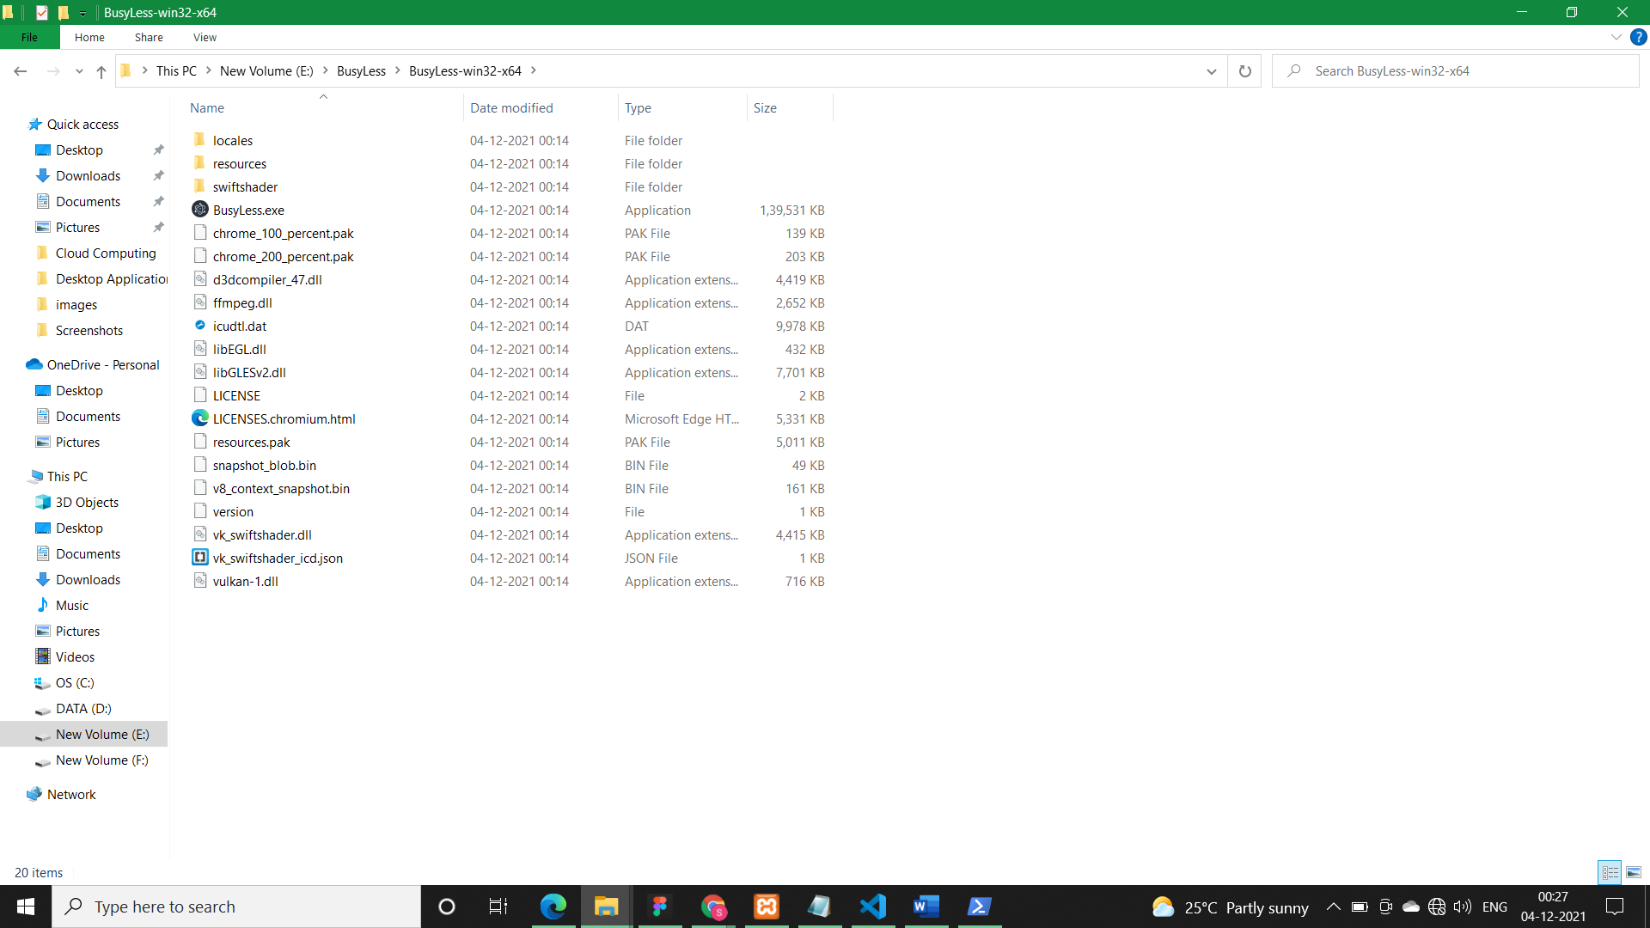

* **Deployment of Application on different machine**:-

I had deployed my application on my friend’s laptop and it was successfully running.

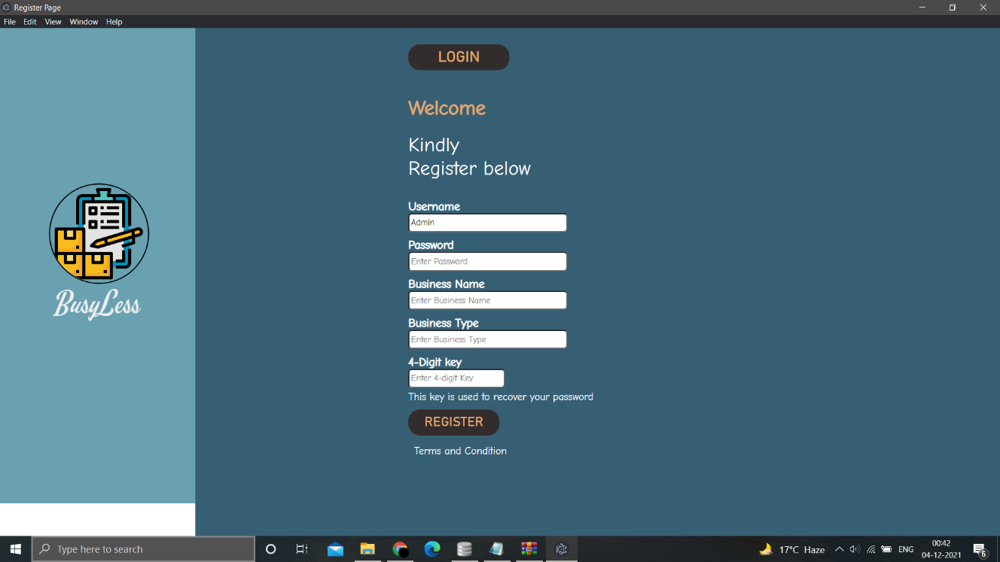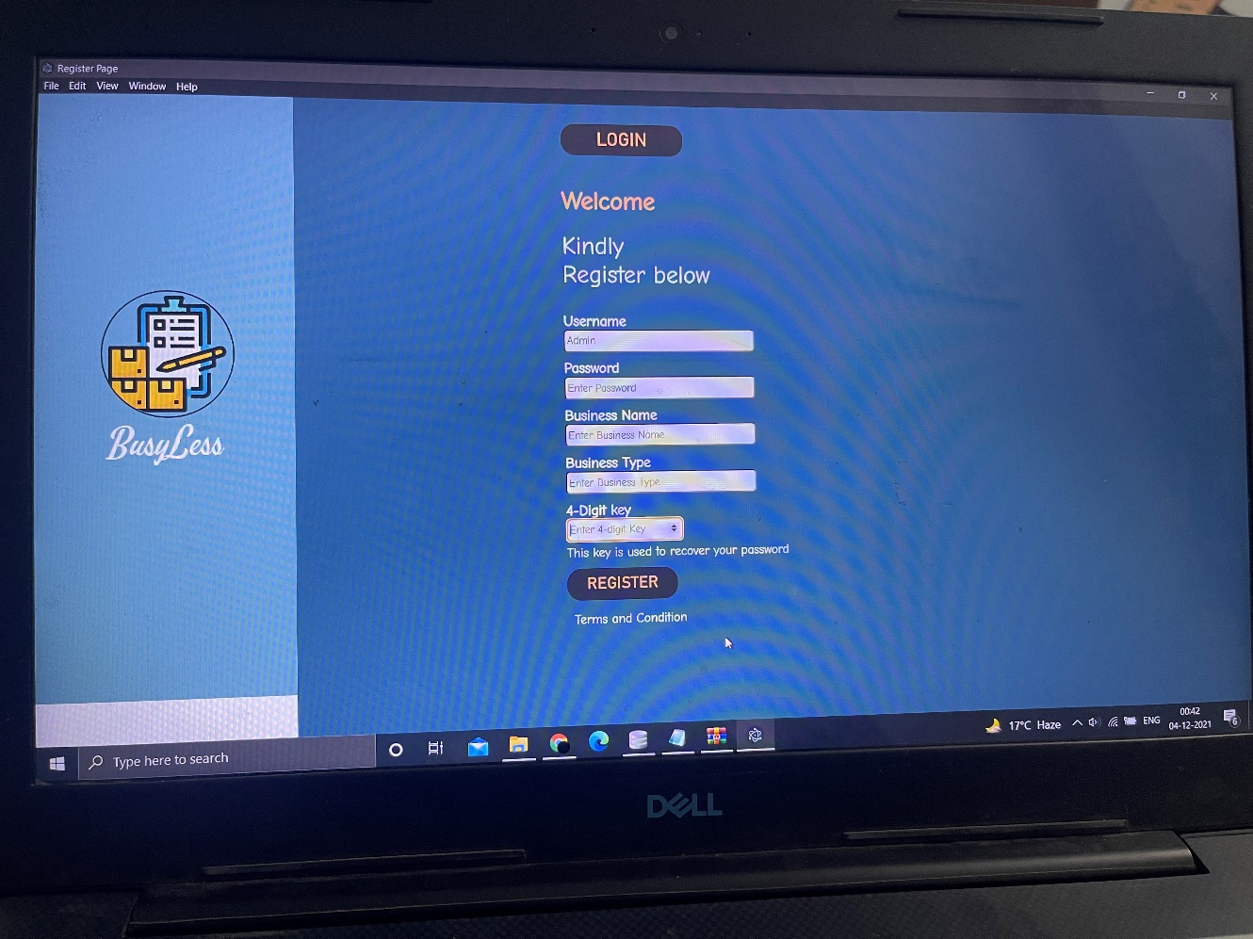

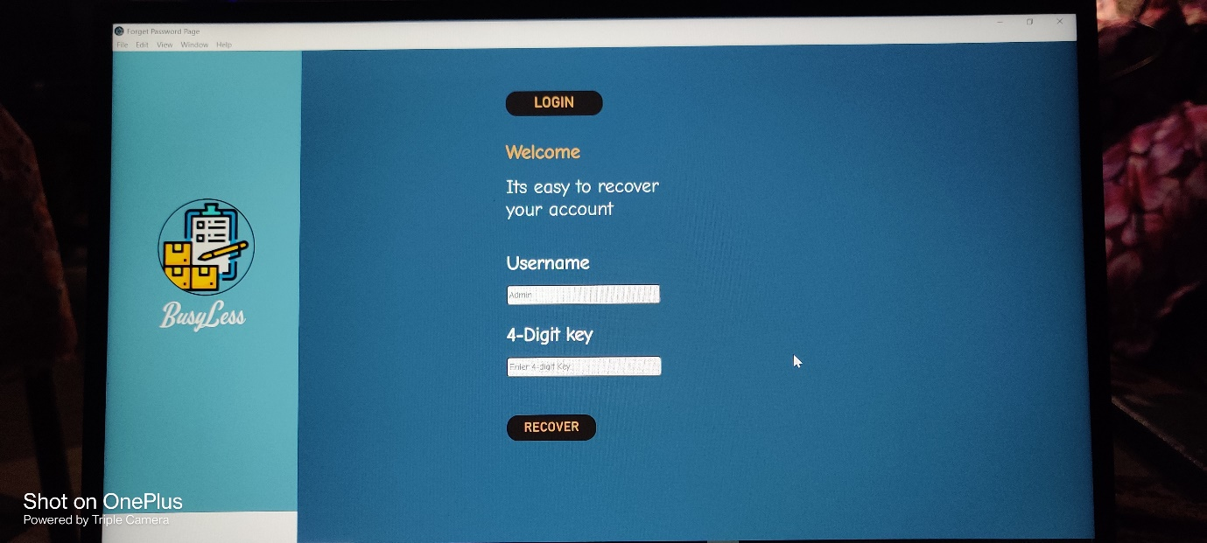

* **Black Box Testing:**

|  |  |  |  |  |
| --- | --- | --- | --- | --- |
| **Snos** | **Test Cases** | **Response time** | **Usability** | **Reliability** |
| 1. | Authentication | Very Quick | 95% | 95% |
| 2. | Authorization | Very Quick | 95% | 95% |
| 3. | User Control and Freedom | Quick | 95% | 95% |
| 4. | Identification of Customer Code | Quick | 80% | 80% |
| 5. | Visibility of system status | Very Quick | 90% | 90% |
| 6. | Processing on Computer itself | Quick | 98% | 98% |
| 7. | Searching by name | Quick | 85% | 85% |
| 8. | API integration | _ | 0% | 0% |
| 9. | Authenticity of Profit values | Quick | 98% | 98% |
| 10. | Taking Goods sold and purchased data from user | Very Quick | 100% | 100% |
| 11. | Analysis data on Desktop Application | Quick | 95% | 95% |
| 12. | Easy Navigation Dashboard | Quick | 95% | 95% |
| 13. | Smart Decisions | Very Quick | 98% | 98% |
| 14. | Alert Notifications | Quick | 80% | 80% |

* **Feedback from Stakeholder: -**

